7. Write a Servlet program to store a user's preferences (like theme or language) using cookies. Retrieve and display these preferences on
subsequent visits.

AIM

To develop a Servlet-based Online Result Collector web application that stores user preferences using cookies and retrieves them on subsequent visits..

ALGORITHM

1. Input:

The user selects theme and department preferences.

2. Form Handling:

• Create an HTML page to accept user preferences.

3. Servlet Processing:

• Create PreferenceServlet to read user inputs.

• Store preferences using cookies.

4. Cookie Retrieval:

• Create DisplayServlet to retrieve cookies and display saved preferences.

5. Deployment:

• Configure web.xml and deploy in Apache Tomcat Server.

6. Output:

• User preferences are stored and displayed on subsequent visits.

SOURCE CODE

index.html

<html>
<head>
<title>Online Result Collector Preferences</title>
<style>
body{
margin:0;
font-family:Arial;
background:linear-gradient(135deg,#2563eb,#0f172a);
display:flex;
justify-content:center;
align-items:center;
height:100vh;
color:white;
}
.container{
background:#111827;
padding:30px;
border-radius:12px;
width:320px;
text-align:center;
}
select,button{
width:100%;
padding:10px;
margin:10px 0;
border:none;
border-radius:5px;
}
button{
background:#2563eb;
color:white;
font-weight:bold;
}
a{color:#93c5fd;}
</style>
</head>

<body>
<div class="container">

<h2>ONLINE RESULT PREFERENCES</h2>

<form action="PreferenceServlet" method="post">

<label>Select Theme</label>
<select name="theme">
<option>Light</option>
<option>Dark</option>
</select>

<label>Select Department</label>
<select name="dept">
<option>CSE</option>
<option>IT</option>
<option>ECE</option>
<option>EEE</option>
</select>

<button type="submit">Save Preferences</button>

</form>

<br>
<a href="DisplayServlet">Go to Result Dashboard</a>

</div>
</body>
</html>

PreferenceServlet.java

import java.io.*;
import javax.servlet.*;
import javax.servlet.http.*;

public class PreferenceServlet extends HttpServlet {

protected void doPost(HttpServletRequest request,HttpServletResponse response)
throws IOException {

String theme = request.getParameter("theme");
String dept = request.getParameter("dept");

Cookie c1 = new Cookie("theme",theme);
Cookie c2 = new Cookie("dept",dept);

c1.setMaxAge(24*60*60);
c2.setMaxAge(24*60*60);

response.addCookie(c1);
response.addCookie(c2);

PrintWriter out = response.getWriter();

out.println("<html><body style='text-align:center;font-family:Arial;margin-top:100px;'>");
out.println("<h2>Preferences Saved Successfully</h2>");
out.println("<a href='DisplayServlet'>Go to Dashboard</a>");
out.println("</body></html>");
}
}

DisplayServlet.java
import java.io.*;
import javax.servlet.*;
import javax.servlet.http.*;

public class DisplayServlet extends HttpServlet {

protected void doGet(HttpServletRequest request,HttpServletResponse response)
throws IOException {

Cookie cookies[] = request.getCookies();

String theme="Light";
String dept="Not Set";

if(cookies!=null) {
for(Cookie c : cookies) {
if(c.getName().equals("theme"))
theme = c.getValue();
if(c.getName().equals("dept"))
dept = c.getValue();
}
}

PrintWriter out = response.getWriter();

if(theme.equals("Dark"))
out.println("<html><body style='background:#111827;color:white;text-align:center;font-family:Arial;'>");
else
out.println("<html><body style='background:#f3f4f6;color:black;text-align:center;font-family:Arial;'>");

out.println("<h1>ONLINE RESULT DASHBOARD</h1>");
out.println("<h2>Saved Theme : "+theme+"</h2>");
out.println("<h2>Saved Department : "+dept+"</h2>");
out.println("<h3>Cookie Preferences Retrieved Successfully</h3>");
out.println("<a href='index.html'>Change Preferences</a>");
out.println("</body></html>");
}
}

web.xml
<web-app>
<welcome-file-list>
<welcome-file>index.html</welcome-file>
</welcome-file-list>
<servlet>
<servlet-name>PreferenceServlet</servlet-name>
<servlet-class>PreferenceServlet</servlet-class>
</servlet>
<servlet-mapping>
<servlet-name>PreferenceServlet</servlet-name>
<url-pattern>/PreferenceServlet</url-pattern>
</servlet-mapping>
<servlet>
<servlet-name>DisplayServlet</servlet-name>
<servlet-class>DisplayServlet</servlet-class>
</servlet>
<servlet-mapping>
<servlet-name>DisplayServlet</servlet-name>
<url-pattern>/DisplayServlet</url-pattern>
</servlet-mapping>
</web-app>

OUTPUT :

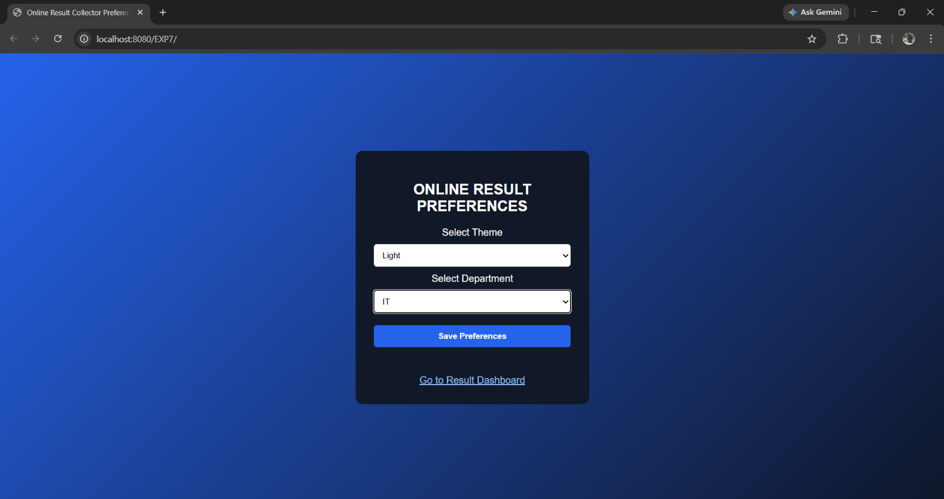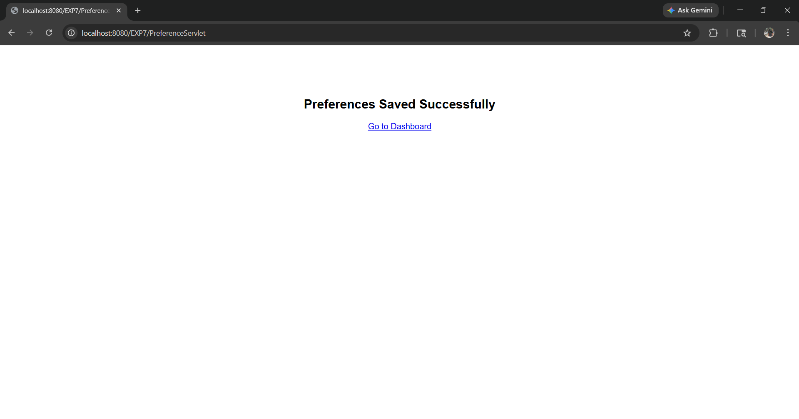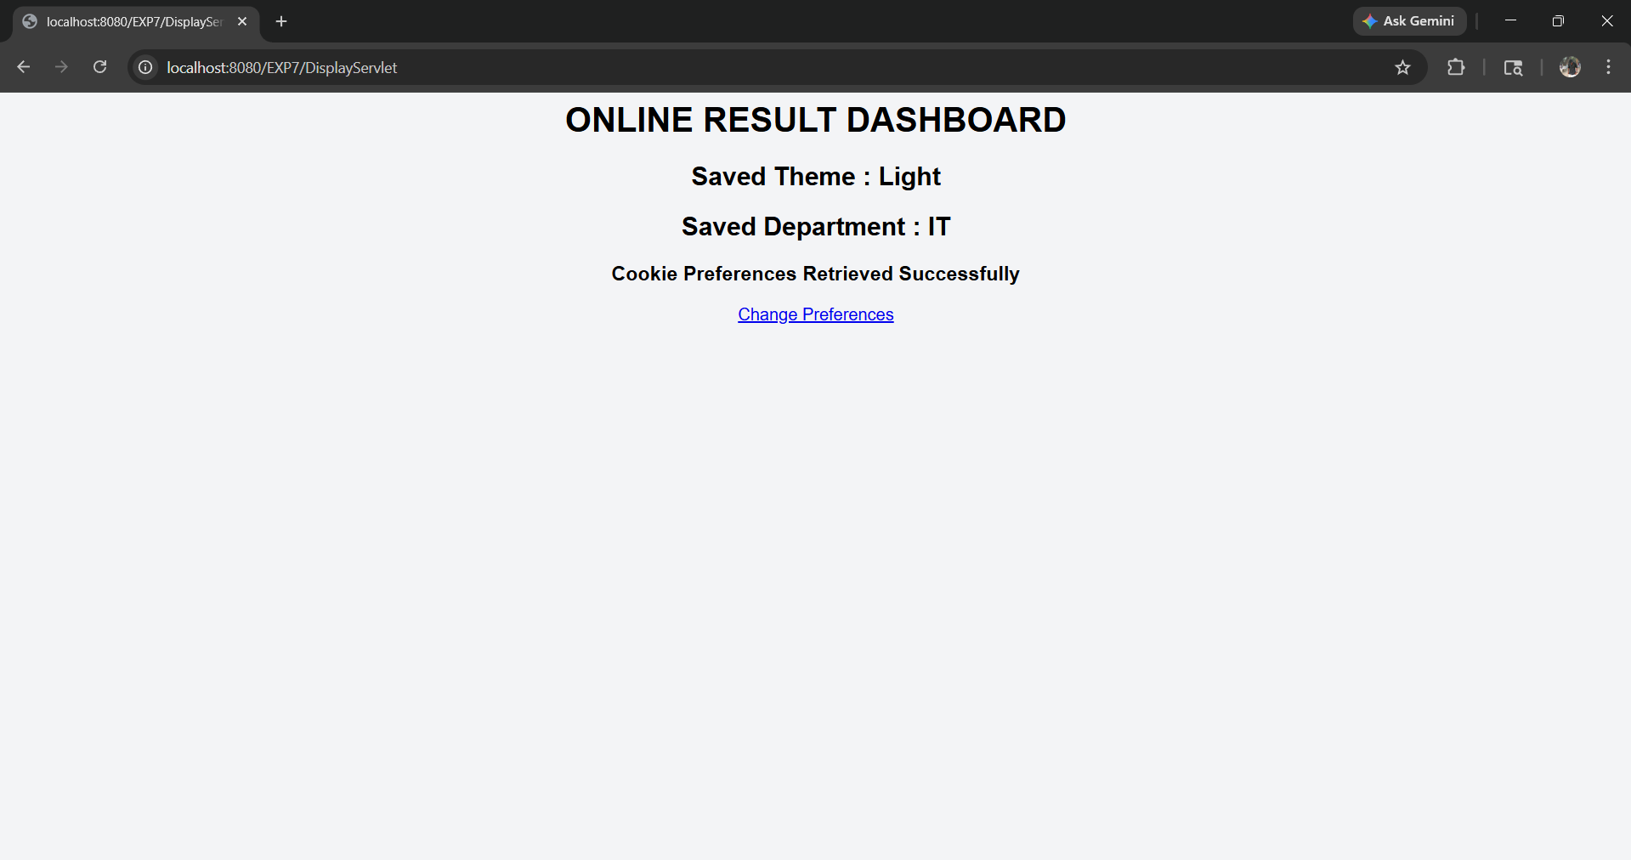

Result:
Thus a Servlet program was created successfully to store user preferences using cookies and retrieve them on subsequent visits in an Online Result Collector web application.

